Austin

Give an example of each of the following concepts in the c# langage. write the code, screenshot it and add it to this document

How to print a message



How to declare ints double and string variables



How to take a string input from the user



How to declare and initialise a boolean variable



How to use arrays

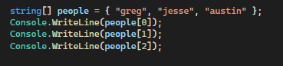

or

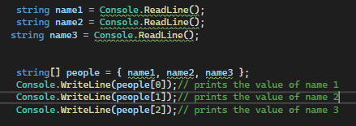

How to use the if conditional statement

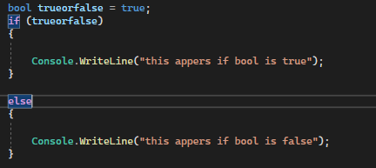

How to use switch statements

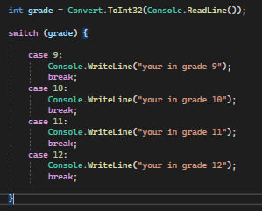

How to use do while loops

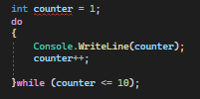

How to use foreach with an array

